***Assignment-7***

***By: Kaviya.C***

**Write a program to create a two packages employeepackage and departmentpackage and under employeepackage create classes like Employee, Manager, Admin ------🡪Employee class:**

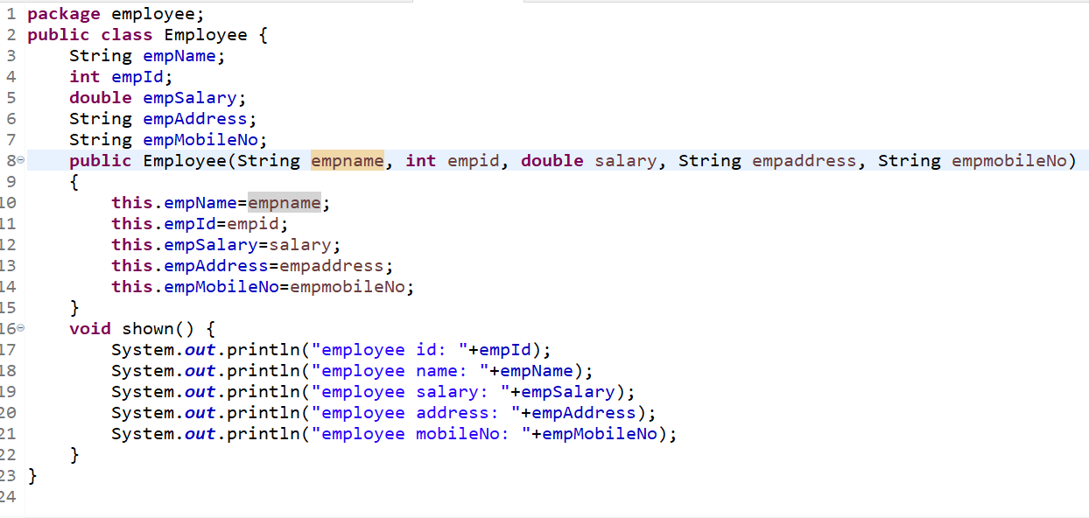

**Manager Class**

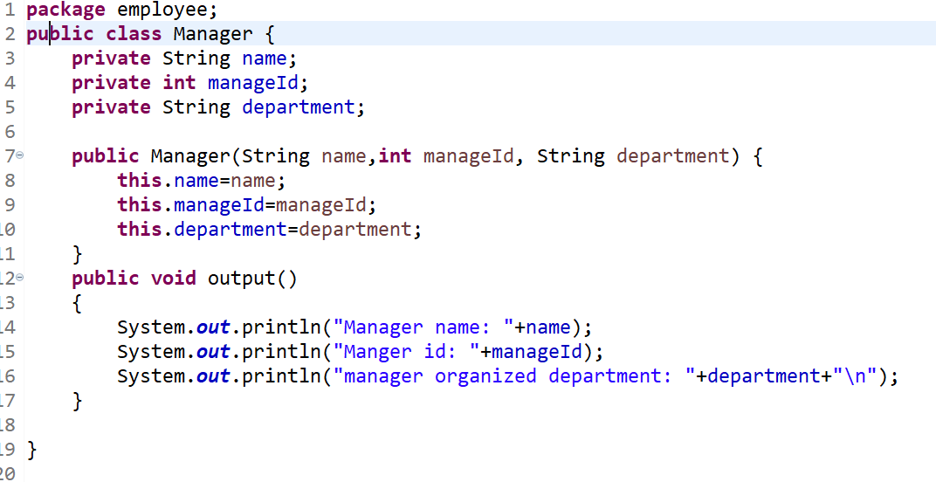

**Admin Class**

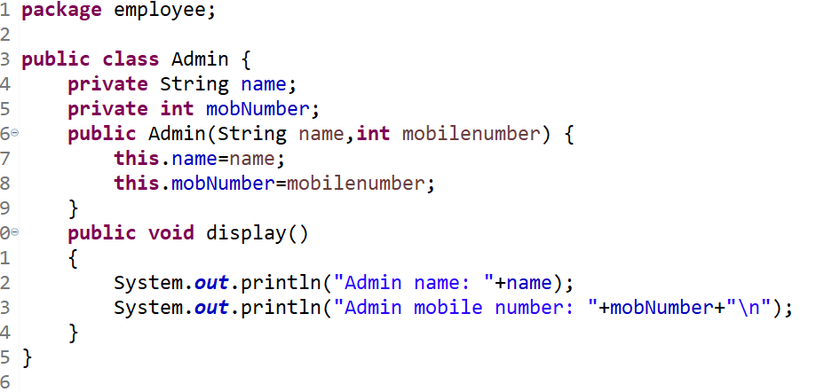

**Under departmentpackage create class by name Department and Project.---------🡪Department Package**

**Department class**

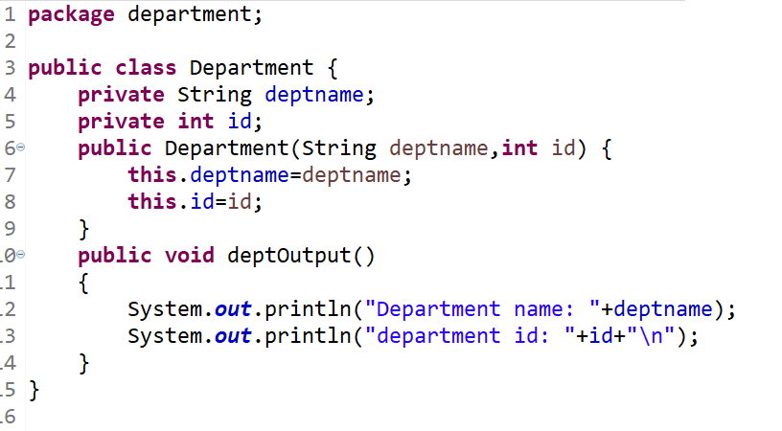

**Project Class**

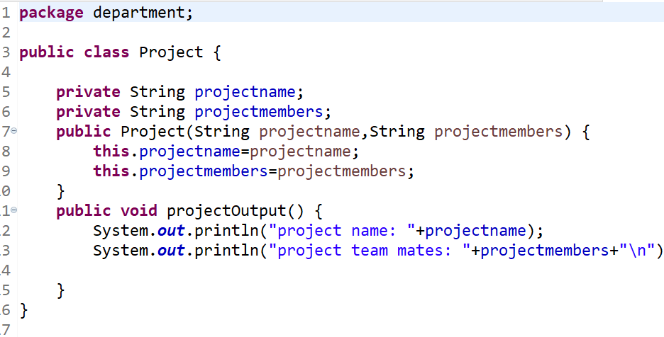

**Create a Main class to test the above classes.**

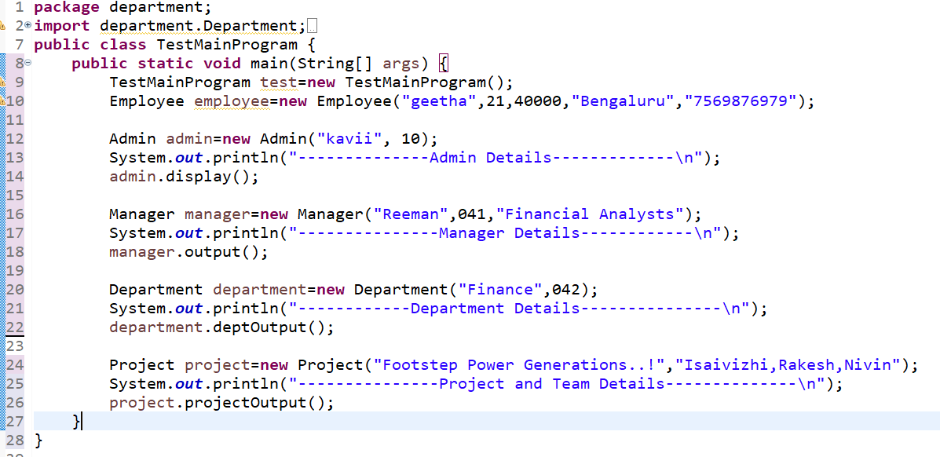

**Output:**

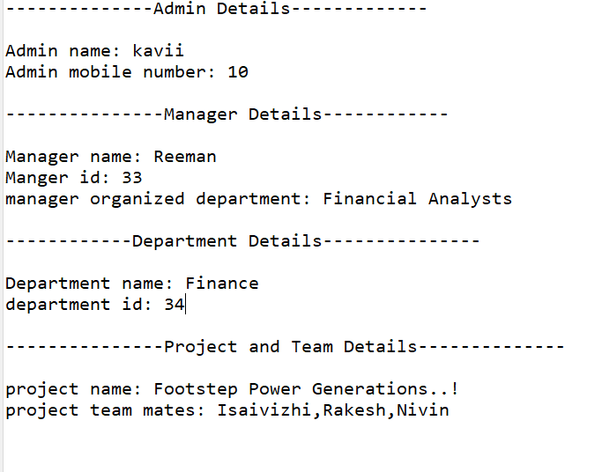

**Write a program to check how many Shape objects created.**

